|  |
| --- |



**Review of the conical pin fin heat sink**

Fatih Korkmaz 1, Montassar Aidi Sharif 2, MSc. student Mohammed Madhat Rashid 1,3

1. Department of Electrical - Electronics Engineering, Çankırı Karatekin University, Turkey.
2. Department of Electronics and Control Engineering, Technical Engineering College- Kirkuk, Northern Technical University.
3. Integrity Commission, Kirkuk Investigation Office, Kirkuk 36001, Iraq.



| **Article Informations** | **ABSTRACT** |
| --- | --- |
| Received: 00 – 00 - 2022  Accepted: 00 – 00 - 2023  Published: 00 – 00 - 2023 | From the beginning of March to the end of August 2022, research is conducted to determine how sensitive monocrystalline solar modules are to variations in environmental factors. |
| **Corresponding Author:**  Mohammed Madhat Rashid  **Email:**  mohammedaga1986@gmail.com |
| **Key words:**  Solar System, Solar Efficiency, Solar Module. |

# Introduction

# The increased energy consumption that accompanied the industrial revolution gave rise to concerns about the environment and the sources of energy, which ultimately resulted in an increase in the average temperature of the earth and a reduction in the utilization of fossil fuels. It is generally accepted that fossil fuels make up more than 80 percent of the world's total energy consumption and serve as the dominant source of energy worldwide [1].

# Photovoltaic Theory

## 2.1 Solar Irradiance

Solar radiation is the most important factor to consider when trying to achieve the desired output power ratio from the PV module. There are two components that make up the irradiance: the initial is the straight ray that travels to the Panel surface, and the second is the reflected irradiance that travels in the opposite direction after being returned from the PV panel surface. It is important to note that the irradiation is not sufficient to provide photovoltaic cells with the energy they need to generate electricity [8]. The direct irradiance that was received by the PV surface can be calculated using Equation 1.

$I_{D}=I_{DN}cosθ……..(1)$

Noted: I*D* is represented the straight irradiance, θ is the direct angle, and I*DN* is direct irradiance.

## 3.Materials and Hypothesis

**3.1 The Methodology**

The test is performed using a three-360 w solar panel installed on a metal stand. The electric parameters like voltage & current were measured to examine the impact of environmental numerous impacts. The impact of fog, dust, dirt, and direct solar at the energy discount turned into evaluated & analyzed. The impact of dust or dirt may be quantified through evaluating the performance of panel uncovered to dirt & without dust or kind or dirt. In this work, the measurements are including a silicon panel of vicinity 2 m2, MTS inverter turned into used for size of producing the the voltage, current, and the temperature and something associated with the solar panel. The experimental examine turned into carried out in the Kirkuk city. The ambient temperature fluctuates between 15 to 50 ºC during the measurements. The sun photovoltaic panel turned into examined and the parameters the power and ambient temperature, etc., wished for the assessment of the structures have been measured at interval of 10 hours between 8 AM and 6 PM. The ambient temperature and the incident solar radiation depth turned into measured the use of the inverter.

**3.2 Experimental Setup**

In this part of the research, an integrated solar energy system was established with a capacity of 1 kilowatts, 3 solar Panels and 2 batteries of 200 amp/hour 360 watts (all information is in Table 1) A smart MTS invertor was used to take measurements and data. Figure 1 represents the practical part and its details that were already explained. It is noted that the solar panels are divided, and this is what can be made good to collect the most possible energy, and even if there is shadow or dust on part of the panels and the cells, the rest of the panel will not be affected as a result of the panel division into two parts, meaning that the first part does not affect the second part and vice versa. The readings were taken as shown in Figure 1, where a laptop was used, and a program was installed to take the readings directly from the inverter that was connected between the batteries and the solar panels.

**Table 1. Specifications of the PV module**

| Parameter | Value |
| --- | --- |
| Model  Average power  Open circuit voltage  Short circuit current  Number of cells  Dimensions  Weight | Tata BP 184459  360 W  12V  2A  60  2*1*0.1 m3  25 kg |

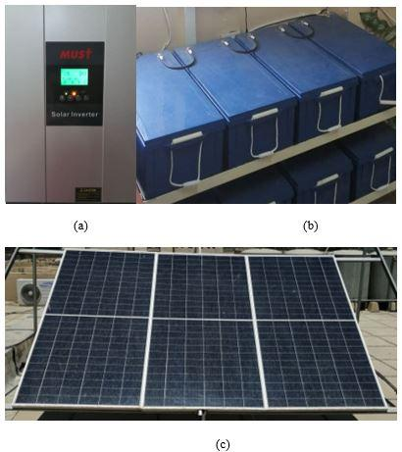

**Figure 1:** Solar panel (360 W) of each panel

# 

**Figure 2**: Full Solar system showing the invertor device and the batteries

# 4.Results

Power results were obtained from data collected during six consecutive months. These results are the Power that was obtained during six months, starting from the month of March until the end of the month of August, and data were collected for all days of the months.

# 5.Conclusions

# A practical investigation was accomplished to test the performance of a solar energy system with a capacity of 1 kilowatt, which is equivalent to three solar panels and one inverter, in addition to two batteries, each with a capacity of 200 amps. Data were collected for 6 consecutive months, starting from the month of March until the end of the month of August. The data was collected by a program specialized in collecting information on solar systems, and after completing the data collection process, the data was analyzed according to months.

# References

# [1] “Intergovenmental panel on climte change,” IPCC Fifth Assessment Report, 2013.

# [2] International Energy Agency, “Key world energy statistics,” International Energy Agency, 82 pages, 2014.

# [3] R. Hill, “Prospects for Photovoltaics,” World Energy, 1999, original data updated by Hynes K. and Hill R. in 1999.

# [4] F. M. Hoffmann, R. F. Molz, J. V. Kothe, E. O. B. Nara, and L. P. C. Tedesco, “Monthlyprofile analysis based on a two-axis solar tracker proposal for photovoltaic panels,” Renew.Energy,vol.115,pp.750–759,2018.